Project management

Assessnent 1

Sang ah Park 70309

|  |  |  |  |
| --- | --- | --- | --- |
| Student Name | Sang ah Park | ID | 70309 |

Assessment 1 – Case Study

Table of Contents

Case Study: Going Green application, Green IT Project Management 2

Project profile 2

Business situation 2

Your tasks: 3

Task 1: Identify Business Strategy and Gap 3

Task 2: Recommend a feasible solution 3

Task 3: Produce a Project Charter 3

Task 4: Project Document 3

Task 5: Project Closure 4

Helpful web links to complete the assessment: 5

**Instruction*:***

This task is to be completed individually. You need to analyse a case scenario and complete all the tasks mentioned after the scenario.

You need to demonstrate your IT project management ability to identify business strategy and gaps. You will also need to suggest a feasible solution to overcome identified gaps and produce a project charter along with a WBS to implement the proposed solution.

**Duration**:

Trainer will set the duration of the assessment.

[**https://one-rainy-day.github.io/project_management**](https://one-rainy-day.github.io/project_management)

# Case Study: Going Green application, Green IT Project Management

## Project profile

Going “Green” is a mission of many companies around the globe not just for reasons of environmental responsibility, but also for cutting costs in these extremely tight economic times. Green IT efforts represent a specific focus area within enterprises that hold attention to this trend. Green IT leverages information technology to streamline operations, cut costly waste, and reduce the impact on the environment. IT typically consumes only about 10% of an organization’s energy costs, but the net effect of a Green IT project is to go beyond just energy saving. To tackle the other 90%, a Green IT project extends into a variety of other departments, and to execute such an endeavor requires an effective project management function in order to identify and prioritize goals. A Green IT transformation can be a complex process.

Vital Statistics:

* Number of project tasks - 12
* Project duration - 16 months
* Project budget - $1,200,000
* Number of users - 50

## Business situation

Summary:

A manufacturer company was asked by the board of directors to implement an enterprise-wide Green IT solution. A Green team was formed for this project. The action plans are:

* revising processes and metrics
* optimizing efficiency of existing IT assets
* revamping architecture and infrastructure
* positioning IT to enable green business practices

# Your tasks:

## Task 1: Identify Business Strategy and Gap

Document the business’s strategies of “Green IT” and also summaries the components required changes for the participating organisation to implement “Green IT Project”. (Min. 300 words)

A manufacturer company is trying to implement Green IT to their business in order to cut costly waste and reduce the impact on the environment. The project duration is set to 16 months and the budget of $1,200,000 is allocated. The expected number of users is 50. Their goal is to accomplish implementing 12 solutions, which includes:

* Server Virtualisation: replacing physical server with virtual server to save power.
* Server Power Capping: allocating power in advance, based on server history.
* Active Power Management: cutting the amount of time the computers are powered.
* Alternative Energy plan: solar, wind or hydro power.
* Computer Hardware Recycling: company issued cell phone.
* Data Center Chargeback Model: determining data centre usage on a per-department basis so more use is charged back more heavily to the department with the most use.
* Data Center Cooling and Airflow: recycling water and collecting rainwater to cool down systems in the data centre.
* Energy Efficient Coding Practices: using query that might save energy even if it takes longer to process.
* Measure Data Center Energy Use: measuring the power usage every 15mins. The goal is to meet a value of 1 in PUE(Power Usage Effectiveness).
* Printer and Display Efficiency: printing both sides of paper and turning of the screen when away.
* Telecommuting Programs: replacing eco unfriendly air travels with virtual work.
* Carbon Footprint Calculator: developing a carbon-footprint calculator.
* Paperless Accounting: encouraging customers to use paperless billing and payments.

## Task 2: Recommend a feasible solution

Assume “Wells International College” is thinking of going “Green” and asked for your assistance in this project. Research different project management applications on the Internet to compare with the Green IT project management application and recommend a feasible solution with proper reasons for Windsor. (Min. 300 words)

A number of solutions have been suggested for the Green IT project. However, some of them are not suitable for Wells International College, because of the differences in their nature and conditions of business.

Thus, I recommend following solutions:

* Server Virtualisation: replacing physical server with virtual server to save power.
* Active Power Management: cutting the amount of time the computers are powered.
* Printer and Display Efficiency: printing both sides of paper and turning of the screen when away.
* Telecommuting Programs: replacing eco unfriendly air travels with virtual work.
* Paperless Accounting: encouraging customers to use paperless billing and payments.

I recommended the solutions above because they:

* do not require a large capital investment.
* are able to be implemented within a short period of time.
* can benefit the business immediately.

While many solutions require capital investment in their system prior to implementation, solutions recommended here do not require a large investment, yet still will benefit the business immediately. The board of directors can make an informed decision for further investment in Green IT after these solutions.

## Task 3: Produce a Project Charter

Develop a project charter for the Windsor project specifying project start date, finish date, approximate budget, project manager, project team with roles and responsibilities, project objective, project approach and stakeholders.

You may follow the “Project Charter” template provided in the “Learner Guide” or find one that meets all the requirements.

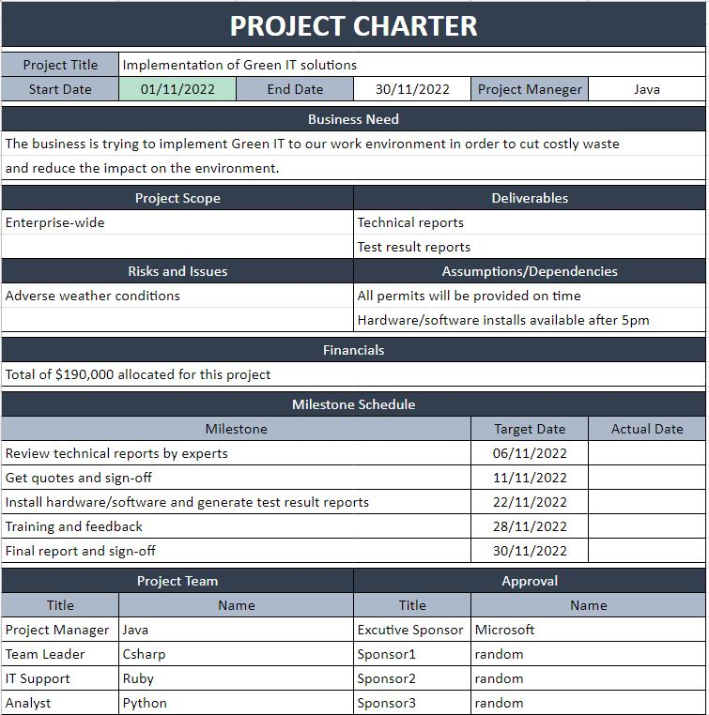

## Task 4: Project Document

Refer to “Go Green” of Well International College (WIC), you have been asked to develop a project plan for WIC. Project plan outline as following:

1. Introduction (Select one recommendation from Task 2 for implement project plan)

**<Implementation of Green IT solutions to WIC>**

Green IT (green information technology) is the practice of environmentally sustainable computing. Green IT aims to minimize the negative impact of IT operations on the environment. However, these practices do not only reduce environmental impact but also help business to save cost and energy. In addition, it will grow brand reputation and attract new customers who are interested in pollution issues.

Therefore, I suggest to implement following Green IT solutions to all departments of WIC.

* Server Virtualisation: replacing physical server with virtual server to save power.
* Active Power Management: cutting the amount of time the computers are powered.
* Printer and Display Efficiency: printing both sides of paper and turning of the screen when away.
* Telecommuting Programs: replacing eco unfriendly air travels with virtual work.
* Paperless Accounting: encouraging customers to use paperless billing and payments.

1. Information gathering plan and approach

Variety of information gathering methods can be used for this project. For example, we can conduct research about customer awareness level and perception of Green IT using a questionnaire and have interview with experts. A questionnaire also can be used to get feedback from end users after implementing solutions.

1. Detail of information repositories

This project related files will be stored both with physical files (5years) and digital means in the data centre.

1. Feasibility studies

Technical feasibility studies will be conducted by external Green IT experts. Operational and economic feasibility test will be conducted internally.

1. Project plan and schedule (Development and Maintenance)

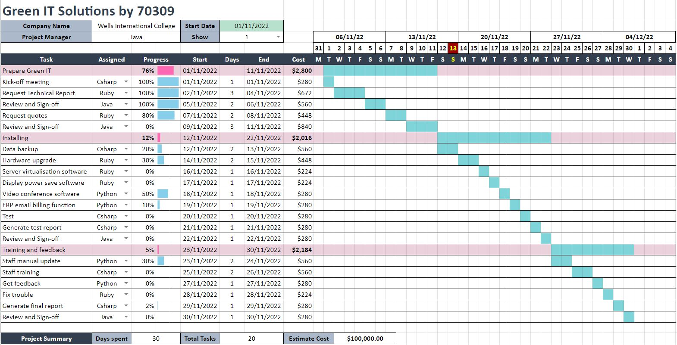

Project schedule is as shown in the Gantt Chart above.

Some milestones are:

* Review technical reports by experts
* Get quotes and sign-off
* Install hardware/software and generate test result reports
* Training and feedback
* Final report and sign-off

Project Deliverables are:

* Technical reports
* Test result reports
* Business manual

Team members will have a meeting once a week to report status, identify issues and check milestone. Schedule management application (Asana) will be used for general schedule management and messaging.

Staff training will be conducted after implementing new systems by team leader and staff manual be updated on intranet.

1. Recourse and budget, (budget has been limited by WIC Capital Expenditure of current fiscal year for Hardware $80,000, Software $10,000, and Outsourcing man-hours $100,000)

The estimated cost is $100,000.

1. Risk Management

Delay due to severe weather conditions.

1. Contingency plan

Important data will be backed up in multiple location before implementation of new system and uninterruptible power supply (UPS) is ready in case of power outage during the backup process.

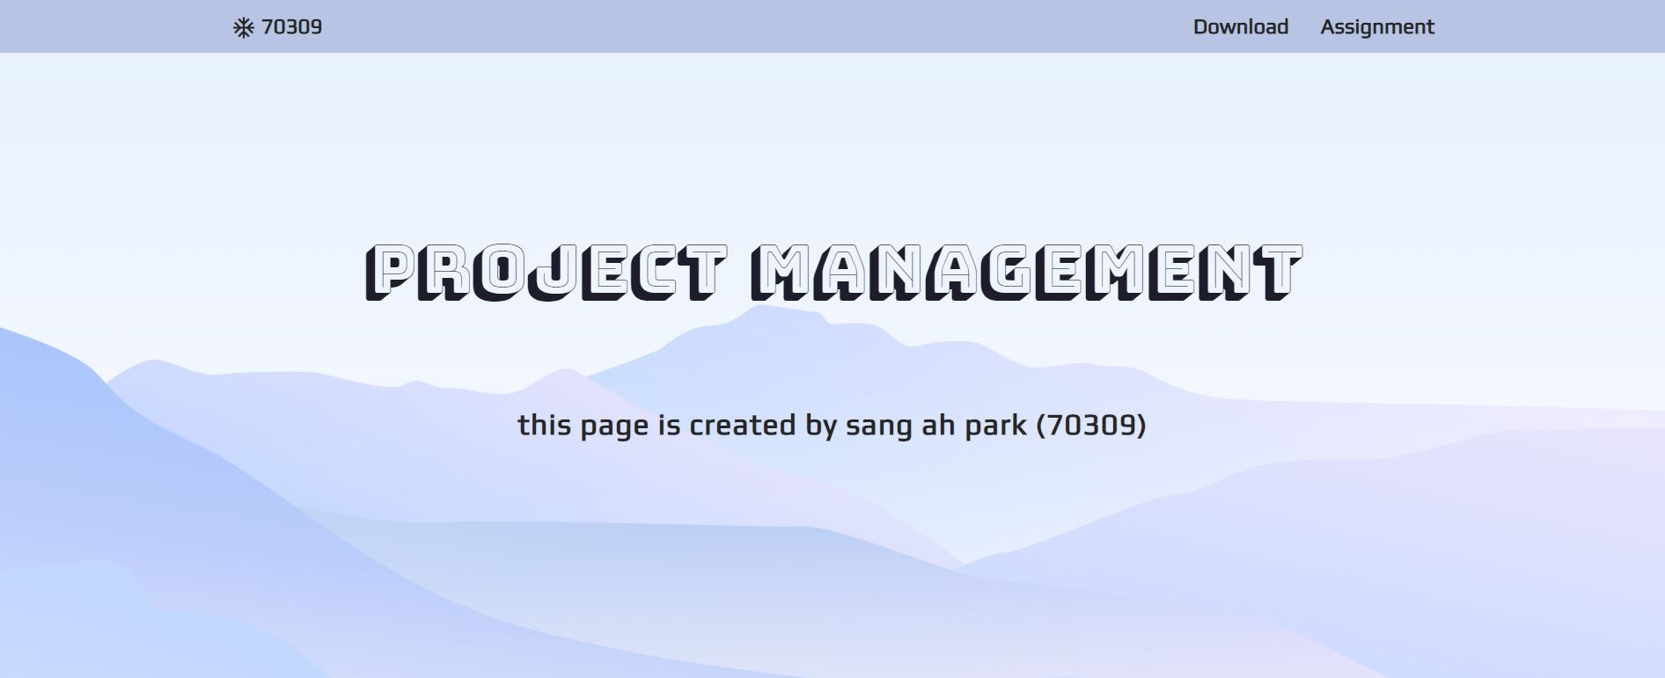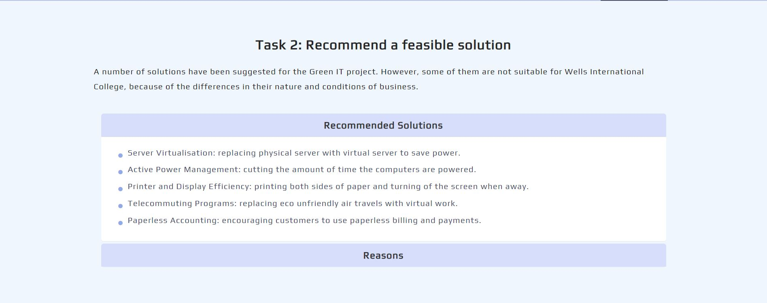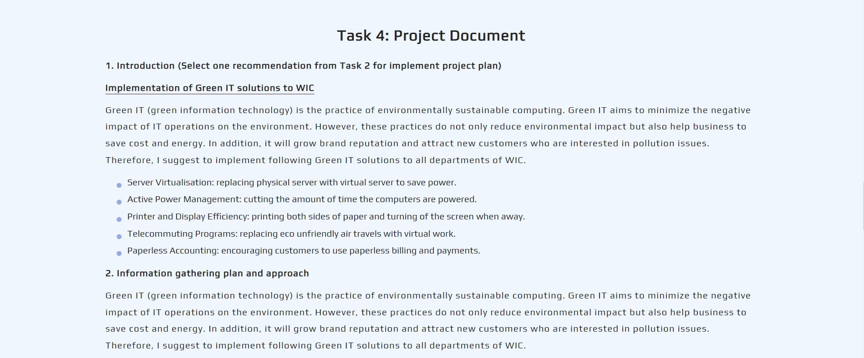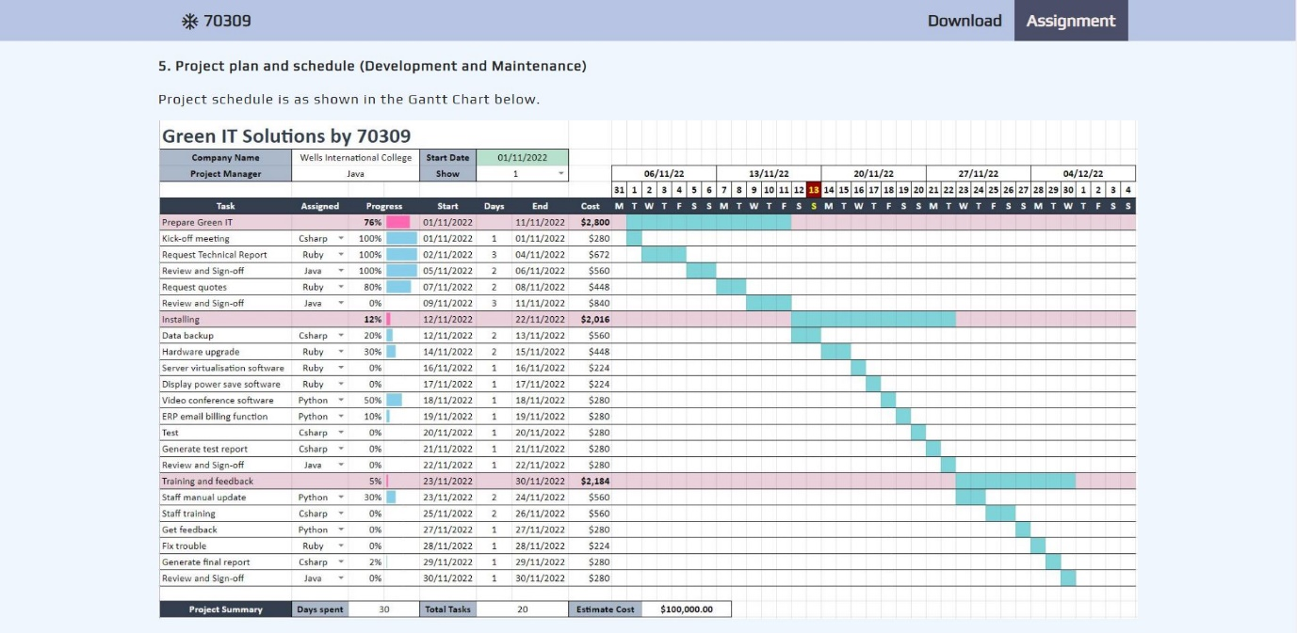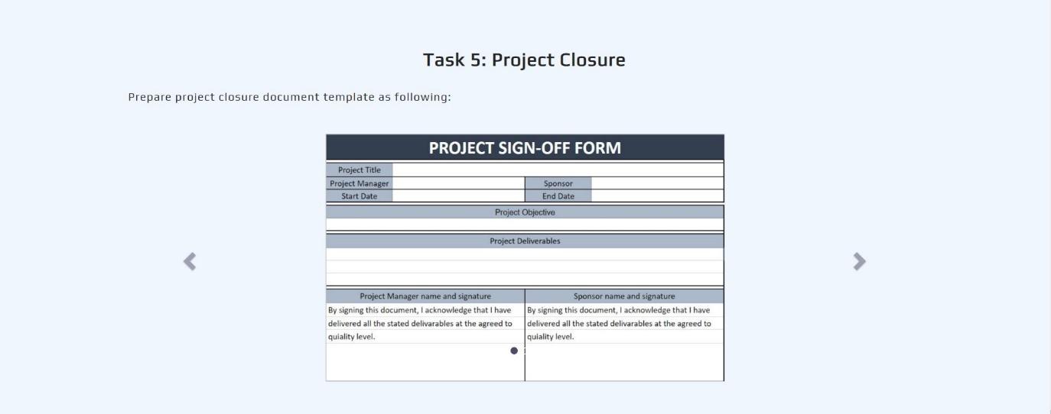

## Task 5: Project Closure

Prepare project closure document template as following:

* Project Sign-off document

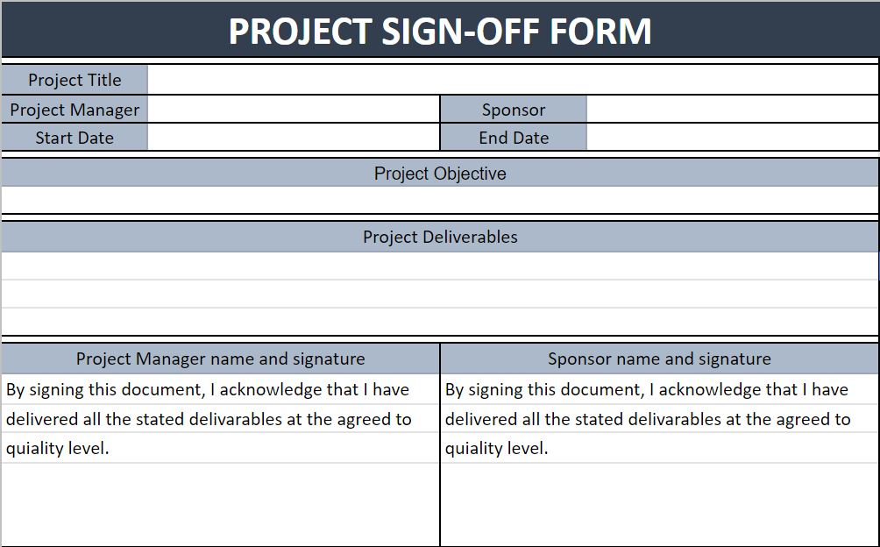

* Project evaluation document

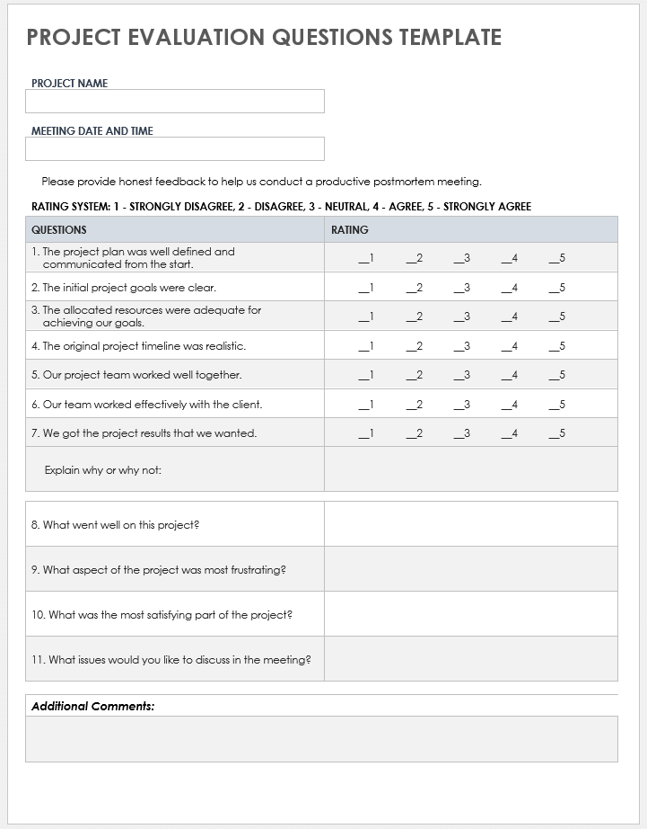

* 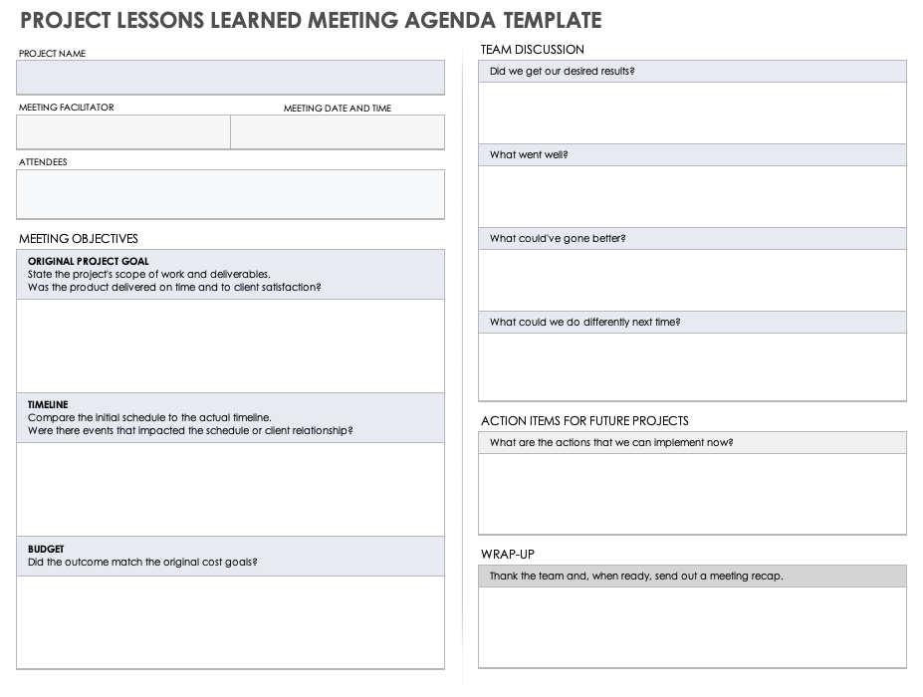Lesson learned template

F

feasible solution 1, 4

P

project sign off 9

S

scenario 1